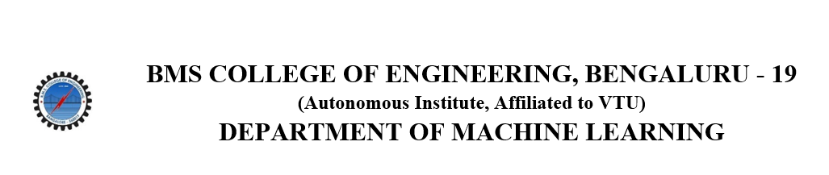
ACTIVITY REPORT
ON
Byte Battle
- Name of the Club: BMSCE ACM STUDENT CHAPTER
- Name of the Activity: Byte Battle
- Objectives: The BMSCE ACM Student Chapter organized a coding competition named “Byte Battle.” This event aimed to foster teamwork, enhance coding skills, and promote competitive programming among participants.
- Date, Time Venue of the Activity:
EVENT | Byte Battle
DATE/DAY | Thursday, 20th June 2024
TIME | 2:00 pm to 4:00 pm
VENUE | PG Block, 2nd floor, Computer Lab
- Name and details of collaborating agency (if it is collaborative/joint activity): IEEE PELS
- Brief summary of the Event: The Byte Battle competition, organized by the BMSCE ACM Student Chapter, was a well-planned event aimed at promoting teamwork and improving coding skills among students. Held on June 20, 2024, in the campus lab, the event lasted around two hours and consisted of multiple rounds that challenged participants in different ways.
The first part of the event, the Byte Battle Challenge, required teams of three to work together to solve coding problems. Each team member was responsible for solving one problem, and the teams had to plan carefully to decide who would handle which task. This round tested their problem-solving abilities and their capacity to work as a team together.

Following the initial challenge, the competition moved into the Watts of Wisdom Round. This segment included a series of quiz questions on topics related to technological innovation and the future of electrification. This round not only tested the participants' coding knowledge but also their understanding of broader technological concepts, adding a new dimension to the competition.

The final round, the Advanced Code Relay Challenge, pushed the teams to tackle more difficult coding problems. Participants took turns coding in short intervals, requiring them to quickly pick up where their teammates left off. This round emphasized the importance of seamless and adaptability under pressure.

Overall, the Byte Battle was a dynamic and engaging event that provided participants with a valuable opportunity to sharpen their coding skills, learn new strategies, and work effectively in teams. The competitive atmosphere and varied challenges ensured that everyone involved had a rewarding and exciting experience.

- Outcomes: The Byte Battle provided participants with an excellent opportunity to enhance their coding skills, collaborate effectively in teams, and develop strategic thinking. The competitive environment and structured challenges prepared participants for real-world coding tasks and competitive programming events.
- Number of participants:
Number of teams | Number of participants
17 | 51

- Two or three relevant Photographs of the activity: (Geo-tagged photos are preferable)

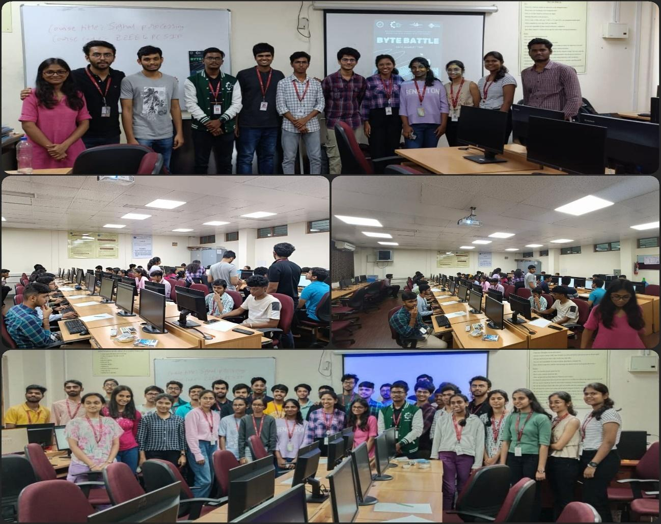

Supporting Documents
a) Attendance sheet
b) Circulars/Brochures
c) Certificates

